Michigan Reconnect Social Media Toolkit

Please use the social media posts below to help us gain support for Michigan Reconnect! Share on your various social media channels through the next few weeks and link back to this landing page - https://www.mcca.org/Michigan-Reconnect

Let’s ask legislators to prioritize funding to support Michigan community college students!

To download the graphics, click here: https://www.dropbox.com/sh/lor83b6h0otbvqp/AADxx6w6jAg15gUlz1LyIM5Ka?dl=0

POST #1
Funding for #Michigan community college students is needed now more than ever. Ask Michigan lawmakers to support Michiganders’ career development. We need your voice! www.mcca.org/Michigan-Reconnect

GRAPHIC
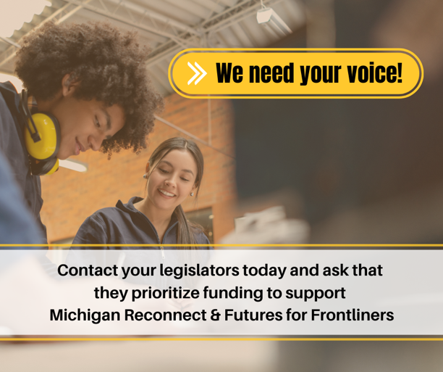

POST #2
Vital support is needed now more than ever for Michigan Reconnect and Futures for Frontliners, but funding for these programs is in jeopardy. We need your voice! www.mcca.org/Michigan-Reconnect

GRAPHIC
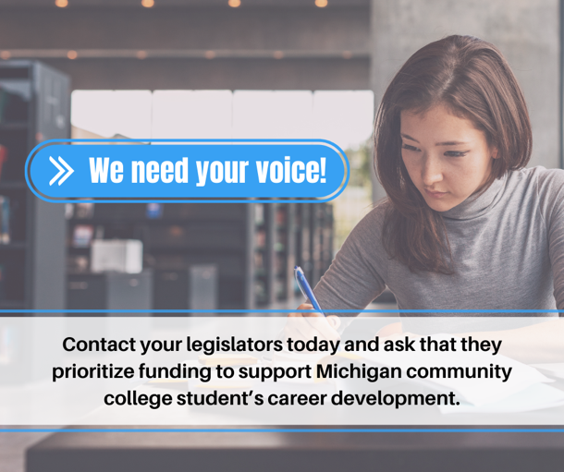

POST #3
Without Michigan Reconnect and Futures for Frontliners, the state would take away skill building and career advancement opportunities from the 150,000 #Michigan residents who applied to participate. www.mcca.org/Michigan-Reconnect

GRAPHIC
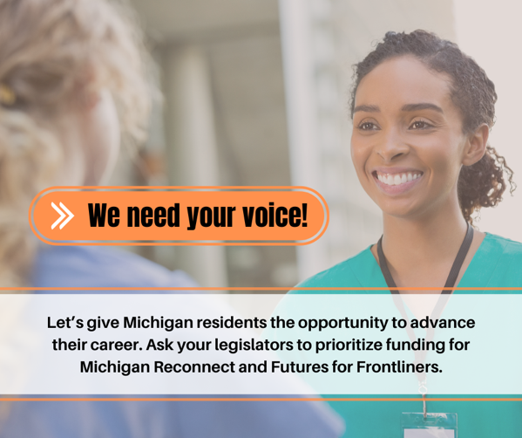

POST #4
We need your voice! Ask your legislators to prioritize funding for free community college education to #Michigan residents aged 25+ or those working on the frontlines of the pandemic. www.mcca.org/Michigan-Reconnect

GRAPHIC
